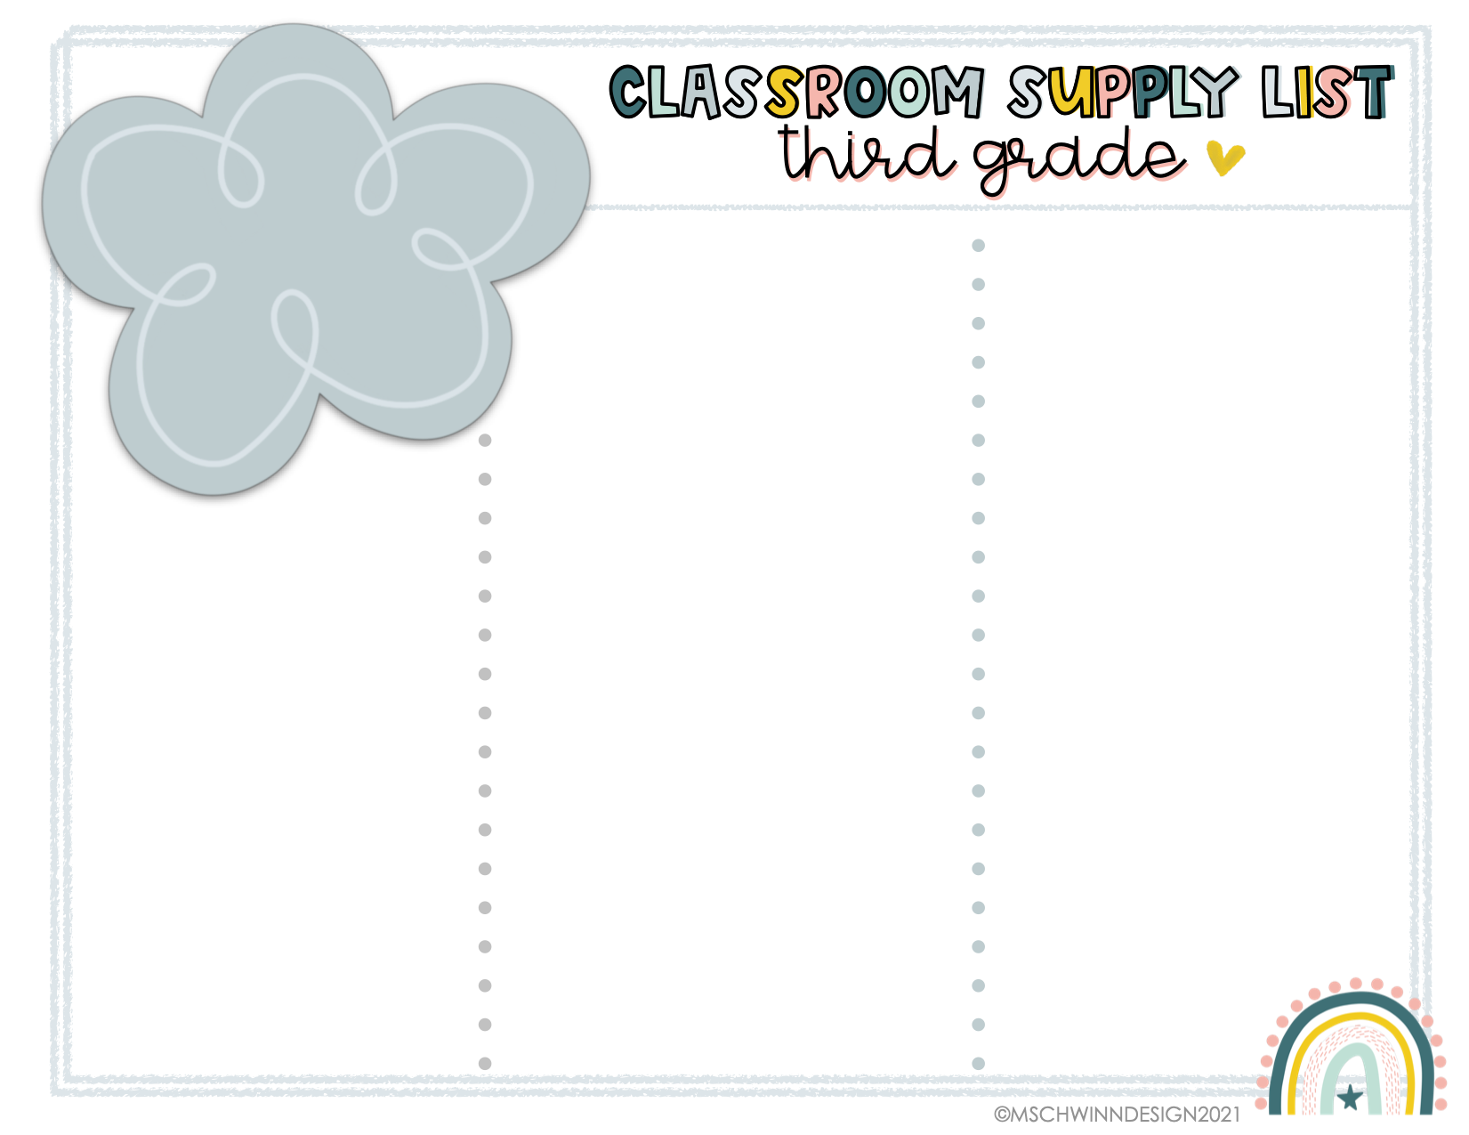

* 5 glue sticks
* 2 Red ballpoint pens
* Blue ballpoint pen
* 4 different color highlighters
* Dry erase marker
* 4-5 pencils
* Pencil sharpener with a cover.
* Kid-friendly scissors
* Small flashlight
* 3 Single-Subject Wide-Ruled Spiral Notebooks
* Headphones
* Mouse (If your child wants)
* 1 composition book
* 1 pack of 24 (or more) colored pencils
* 1 pack of washable markers
* 5 different colored writing pens (for taking notes)
* 1 box of 24 crayons
* Ruler
* Black Sharpie Pen (Fine tip and/or ultra fine tip)
* Post-its (any color, any size)
* Personal water bottle to refill
* White board eraser (a sock works fine)
* Small pencil box to hold your items in for the classroom.

***\* You may want a duplicate of some items for home to use for homework***

***\*Make sure EVERYTHING is labeled with your name.***

**Optional Classroom Donations**:

*Clorox Wipes (We need lots!)

*Liquid/Foam hand soap

*Kleenex

*Paper Towels

*Glue Sticks (We need lots!)

*Post-its

*Sharpie pens (Fine/Ultra fine) (Black & multi color)

*Ziplock Baggies (Snack, Sandwich, Quart, Gallon)

*Whiteboard Pens

*Reward Items: bookmarkers, small toys, poppers, key chains, craft items, etc.

2023-2024

Mrs. Shuler